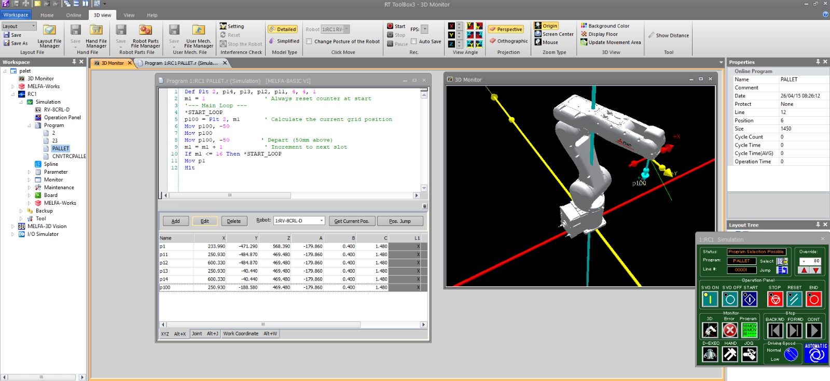
Figure 1: Integrated environment for programming, coordination, and simulation.

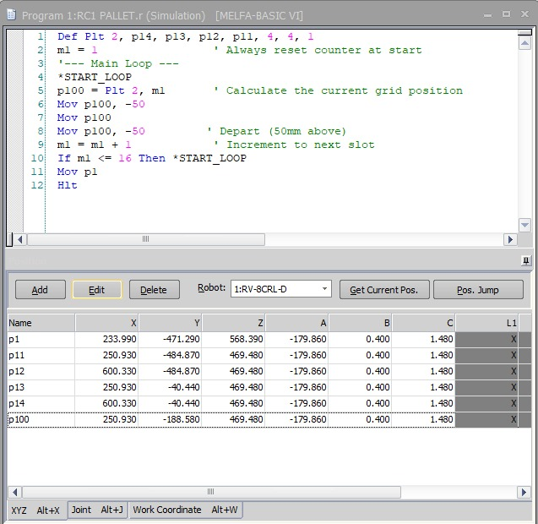
Figure 2: Grid iteration with defined parameters and boundary inputs.
Expt No:  04 | DISCRETE MATRIX PALLETIZING
Date:
25 / 02 /2026

- AIM:
To synthesize a 4x4 spatial storage matrix using discrete grid logic within a simulated engineering environment, and to subsequently validate the dynamically calculated coordinate trajectories through live physical execution on a 6-axis industrial manipulator.
- APPARATUS REQUIRED:
  - Robotic System: Mitsubishi RV-8CRL-D industrial manipulator.
  - Control Hardware: CR800-Series Controller and Teaching Pendant.
  - Software Suite: RT ToolBox3 integrated engineering environment.
  - Infrastructure: 16-point physical pallet base fixture mounted within the work envelope.
  - End-of-Arm Tooling (EOAT): Pointing effector or standard gripper configured to the tool coordinate system.

- THEORY:
- Core Principle:
In industrial automation, trajectory logic is first designed and simulated virtually to ensure mathematical accuracy and collision avoidance. Once the spatial discretization (the mathematical mapping of the physical workspace) is verified, the logic is deployed to the physical controller.
- Working Mechanism:
  - Pallet Definition (Def Plt): The instruction establishes a localized 4x4 coordinate matrix mapped to Pallet 2. It is geometrically defined by physically teaching four absolute boundary coordinates (p14, p13, p12, p11) using the teaching pendant and syncing them to the software.
  - Routing Pattern Generation: The final parameter in the Def Plt syntax (1) dictates the routing pattern. This forces the controller's algorithm to alternate the directional sequencing for each row (a zig-zag pattern), optimizing physical cycle time by minimizing unnecessary joint travel.
  - Dynamic Coordinate Calculation: An index counter (m1) tracks grid saturation. The intermediate target variable (p100) is dynamically calculated and overwritten during each physical loop iteration.
- Key Formula:
The absolute spatial target coordinate for the current cycle is derived dynamically by the controller:
$$P_{100}=Plt(2,m_{1})$$

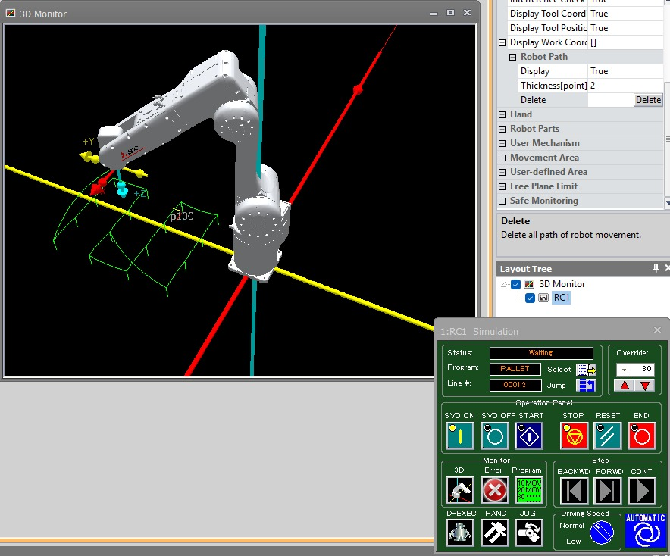
Figure 3: Simulated approach toward a dynamic target.

- PROCEDURE:
  - Setup & Configuration:
Secure the physical pallet fixture. Using the teaching pendant, manually jog the RV-8CRL-D to teach the exact physical coordinates of the four corners (p11, p12, p13, p14) and a safe global origin (p1). Synchronize these coordinate registries with the RT ToolBox3 workspace.
  - Algorithm & Logic:
    - Declare the 4x4 pallet array (Pallet 2) with pattern type 1.
    - Initialize the sequential counter (m1 = 1).
    - Enter the main execution loop (*START_LOOP).
    - Calculate the spatial placement node p100 for the current index.
    - Execute a joint-interpolated approach to p100 with a -50mm vertical Z-offset.
    - Move linearly to the exact physical contact node p100.
    - Execute a vertical linear departure to the -50mm Z-offset to clear the grid dividers.
    - Increment the counter m1 and loop until the 16th node is traced.
    - Return to the safe origin (p1) and halt execution.
  - Execution Steps:
    - Simulation Phase: Input the logic into the RT ToolBox3 Program Editor. Utilize the 3D Monitor to verify the toolpaths and ensure the -50mm offsets execute correctly without simulated collisions.
    - Deployment: Write the verified program and position data directly to the physical CR800-D controller via the TCP/IP or USB interface.
    - Physical Verification: Using the teaching pendant, initiate a Step Run at a low override speed (e.g., 10%) to visually verify the physical TCP aligns with the physical pallet fixture.
    - Auto Execution: Transition the controller to Automatic mode and execute the full kinematic sequence at operational speed.
  - Observation Instructions:
During live execution, observe the mechanical smoothness of the zig-zag trajectory transitions. Verify that the physical end-effector perfectly aligns with the center of each of the 16 pallet nodes without any cumulative drift.

- RESULT AND OBSERVATION:
The robotic system successfully validated the simulated 4x4 matrix palletizing logic through live physical execution. Dynamic coordinate mapping accurately guided the manipulator across the grid, and strict vertical approach/escape offsets ensured collision-free navigation, as verified by faculty evaluation.

